For Registrar’s Use only
Code # BU11 (2014)
New Emphasis/Concentration or Option Proposal-Bulletin Change Transmittal Form
☐ Undergraduate Curriculum Council - Print 1 copy for signatures and save 1 electronic copy.
New Certificate or Degree Program (The following critical elements are taken directly from the Arkansas Department of Higher Education’s “Criteria and Procedures for Preparing Proposals for New Programs”.) Please complete the following and attach a copy of the catalogue page(s) showing what changes are necessary..

___________________ Enter date…  Department Curriculum Committee Chair | ___________________ Enter date…  COPE Chair (if applicable)
___________________ Enter date…  Department Chair: | ___________________ Enter date…  General Education Committee Chair (If applicable)
___________________ Enter date…  College Curriculum Committee Chair | ___________________ Enter date…  Undergraduate Curriculum Council Chair
___________________ Enter date…  College Dean | ___________________ Enter date…  Graduate Curriculum Committee Chair
___________________ Enter date…
Vice Chancellor for Academic Affairs

1. Proposed Program Title
Bachelor of Science in Management, International Business Emphasis

2. CIP Code Requested
52.1403

3. Contact Person (Name, Email Address, Phone Number)
Dr. Melodie Philhours, mphil@astate.edu, 870-680-8148

4. Proposed Starting Date
7/1/2015

From the most current electronic version of the bulletin, copy all bulletin pages that this proposal affects and paste it to the end of this proposal.
To copy from the bulletin:
- Minimize this form.
- Go to http://registrar.astate.edu/bulletin.htm and choose either undergraduate or graduate.
- This will take you to a list of the bulletins by year, please open the most current bulletin.
- Find the page(s) you wish to copy, click on the “select” button and highlight the pages you want to copy.
- Right-click on the highlighted area.
- Click on “copy”.
- Minimize the bulletin and maximize this page.
- Right-click immediately below this area and choose “paste”.
- For additions to the bulletin, please change font color and make the font size larger than the surrounding text. Make it noticeable.
- For deletions, strike through the text, change the font color, and enlarge the font size. Make it noticeable.

MANAGEMENT PROGRAM:
Management is getting work done through other people. Managers perform a wide range of workplace activities, from establishing organization goals and ensuring progress towards those goals to organizing when and how activities and resources should be grouped together. Managers are asked to solve challenging workplace problems, often with limited human and financial resources. The Management major prepares students to design rewards for improved performance, set goals that motivate workers, and build an environment to create and sustain a competitive advantage. Elective concentration may be chosen in Human Resource Management, Hospitality Management, or International Business.

Page 154
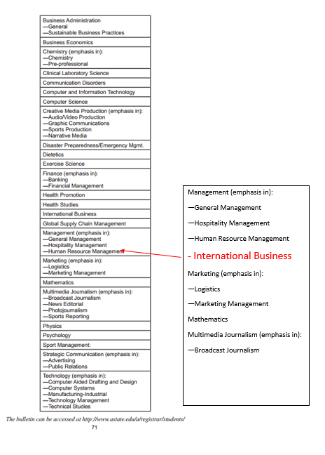

INSERT AFTER PAGE 159 & BEFORE 160
Major in Management
Bachelor of Science
Emphasis in International Business
University Requirements:
See University General Requirements for Baccalaureate degrees (p. 41)
(For College of Business requirements, see p. 132)
First Year Making Connections Course: | Sem. Hrs.
BUSN 1003, First Year Experience Business | 3
General Education Requirements | Sem. Hrs.
See General Education Curriculum for Baccalaureate degrees (p. 84)  Students with this major must take the following:  MATH 2143, Business Calculus with a “C” or better.  ANTH 2233, Introduction to Cultural Anthropology OR  SOC 2213, Introduction to Sociology  ECON 2313, Principles of Macroeconomics  COMS 1203, Oral Communications (Required Departmental Gen. Ed. Option) | 35
College of Business Core Courses: | Sem. Hrs.
(See Beginning of Business Section) | 39
Major Requirements: | Sem. Hrs.
MKTG 3023, Applied Research | 3
MGMT 3123, Principles of Management | 3
MGMT 3143, Human Resource Management | 3
MGMT 3613, Leadership | 3
MGMT 4163, Small Business Management | 3
Sub-total | 15
Emphasis Area (International Business): | Sem. Hrs.
MKTG 4223, International Marketing | 3
ECON 4143, Export Policies & Procedures | 3
FIN 3813, International Financial Management | 3
MKTG 4133, International Logistics | 3
MGMT 4123, International Management | 3
Select one of the following:  ECON 4103, International Trade  CIT 4453, Global eCommerce  MGMT 3193, Social Impact Management  ECON 4363, Global Environmental Policies  IB 4133, International Law  IB 3013, Global Leadership  IB 4283, International Business Practicum | 3
Sub-total | 18
Electives: | Sem. Hrs.
Electives | 10
Total Required Hours: | 120
A complete 8-semester degree plan is available at http://registrar.astate.edu/.

LETTER OF NOTIFICATION – 3
NEW OPTION, CONCENTRATION, EMPHASIS
(Maximum 18 semester credit hours of new theory courses and 6 credit hours of new practicum courses)

1. Institution submitting request:
Arkansas State University, College of Business, Department of Management & Marketing

2. Contact person/title:
Dr. Melodie Philhours, Chair, Management & Marketing Department

3. Phone number/e-mail address:
870-680-8148/mphil@astate.edu

4. Proposed effective date:
Fall 2015

5. Title of degree program:
Management, International Business Emphasis, B.S.

6. CIP Code:
52.1403

7. Degree Code:
2860

8. Proposed option/concentration/emphasis name:
International Business Emphasis

9. Reason for proposed action:
Global issues impact many businesses. This program is designed to prepare students for management positions both domestic and abroad, in local organizations as well as worldwide. In addition to the basic management curriculum, students who seek the IB emphasis will have training uniquely qualifying them to secure professional positions in multinational organizations worldwide and in local organizations in increasingly diverse labor and customer markets.

10. New option/concentration/emphasis objective
The objective of the Management, International Business Emphasis is to provide students with a strong and specific skill, management, along with more general international business knowledge in economics, finance, management, and logistics. This combination of course work will deliver management theory combined with international business knowledge needed to manage an international company, an international customer market, or to guide strategy in multinational organizations both for-profit and non-profit.

11. Provide the following:
a. Curriculum outline - List of required courses
FYE & General Education Courses – 38 hours
College of Business Core Courses – 39 hours
Electives – 10 hours
Management Core Courses – 15 hours
MKTG 3023 – Applied Research
MGMT 3123 – Principles of Management
MGMT 3143 – Human Resource Management
MGMT 3613 – Leadership
MGMT 4163 – Small Business Management
International Business Emphasis Courses –18 hours
MKTG 4223, International Marketing
ECON 4143, Export Policies & Procedures
FIN 3813, International Financial Management
MKTG 4133, International Logistics
MGMT 4123, International Management
Select one of the following:
ECON 4103, International Trade
CIT 4453, Global eCommerce
MGMT 3193, Social Impact Management
ECON 4363, Global Environmental Policies
IB 4133, International Law
IB 3013, Global Leadership
IB 4283, International Business Practicum

b. New course descriptions
No new courses are required.

c. Program goals and objectives
The objective of this program is to prepare graduates for careers in management in organizations both domestic and international through the discovery, analysis, application and creation of strategies designed for international markets and the impact of international markets and competitors upon organizations.

d. Expected student learning outcomes
Students in this program should be able to demonstrate knowledge and skills in the following areas:
1. Business Knowledge – both general and specific to this emphasis area
2. Written and Oral Communication
3. Technology Used Effectively
4. Ethical Decision Making
5. Intercultural/Diversity Perspectives

12. Will the new option be offered via distance delivery?
No

13. Mode of delivery to be used:
Mode of delivery will vary according to course and will include lecture, independent research, and internships.

14. Explain in detail the distance delivery procedures to be used:
None

15. Is the degree approved for distance delivery?
No

16. List courses in option/concentration/emphasis. Include course descriptions for new courses.
International Business Emphasis Courses –18 hours
MKTG 4223, International Marketing
ECON 4143, Export Policies & Procedures
FIN 3813, International Financial Management
MKTG 4133, International Logistics
MGMT 4123, International Management
Select one of the following:
ECON 4103, International Trade
CIT 4453, Global eCommerce
MGMT 3193, Social Impact Management
ECON 4363, Global Environmental Policies
IB 4133, International Law
IB 3013, Global Leadership
IB 4283, International Business Practicum

17. Specify the amount of the additional costs required, the source of funds, and how funds will be used.
At current enrollment levels no additional costs are needed. All of these courses are currently being taught in support of the International Business and various other majors within the College of Business, albeit most with only one section. When demand for the emphasis area grows, as anticipated, additional faculty may be needed to offer additional sections of these courses.

President/Chancellor Approval Date: Enter date... | ___________________ Enter date…  Vice Chancellor for Academic Affairs
Board of Trustees Notification Date: Enter date...

